DYNAMIC TABLES
Dynamic tables are those which continuously materializes the query results based on target lag you have given to it
Syntax for creating Dynamic tables
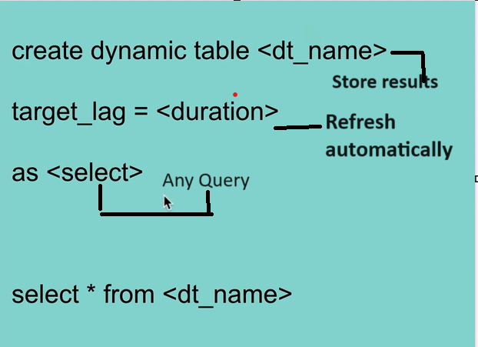
When we create dynamic tables,
- Results are immediate
- Refreshes with in the duration
- Write does not affect read

Following are the syntaxes on dynamic tables that you can alter
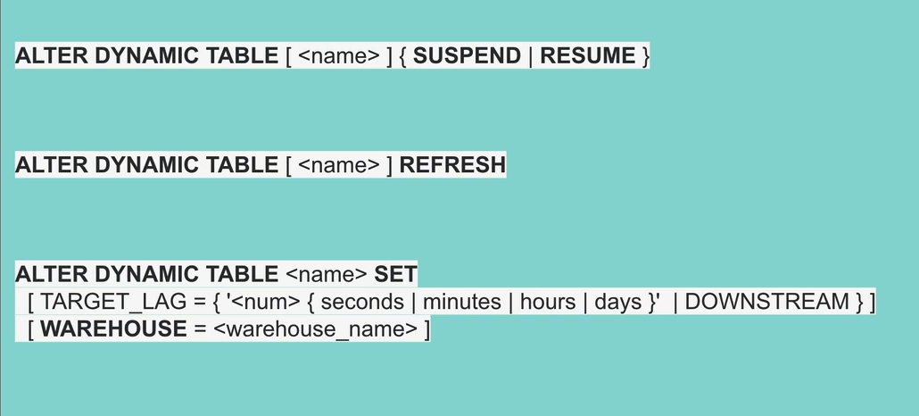
Features of dynamic tables
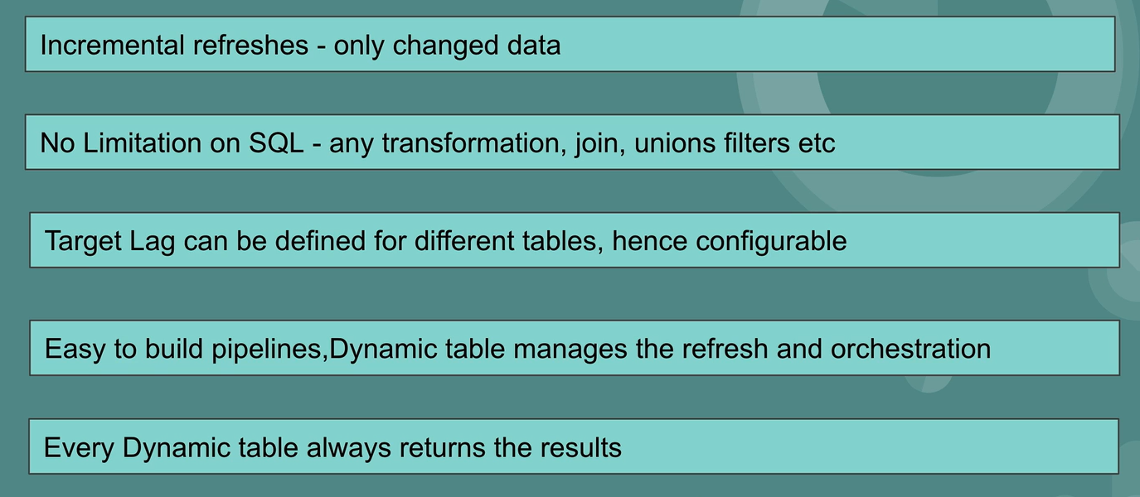
Dependency Graph
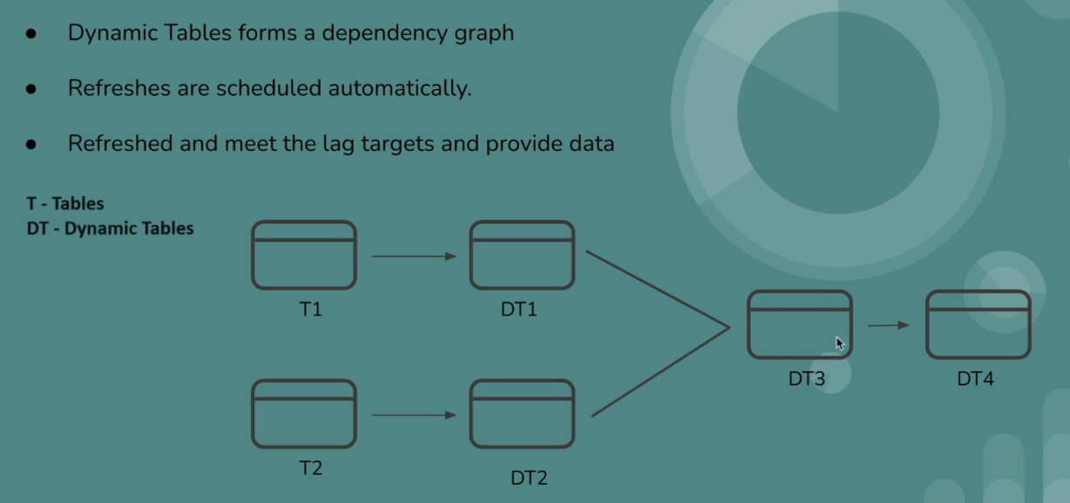

Now, let’s do it in practical
Creating a table
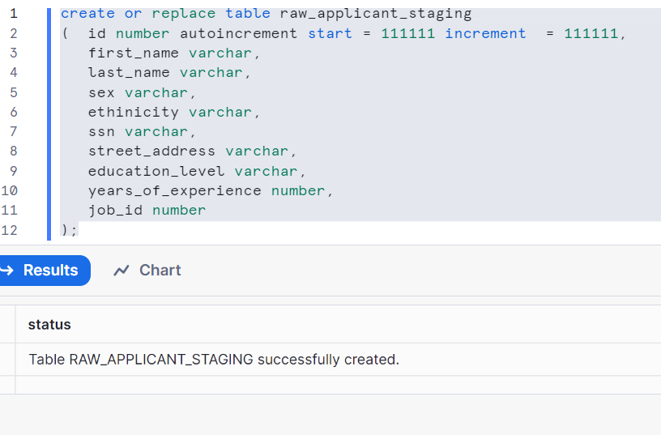
Let’s insert two records
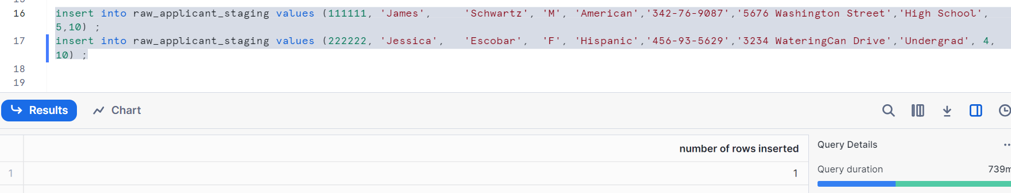
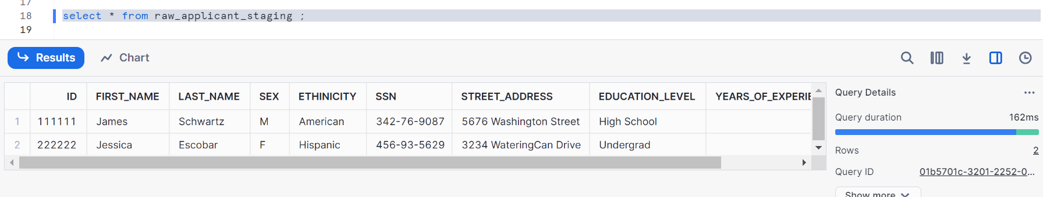

Create one more table
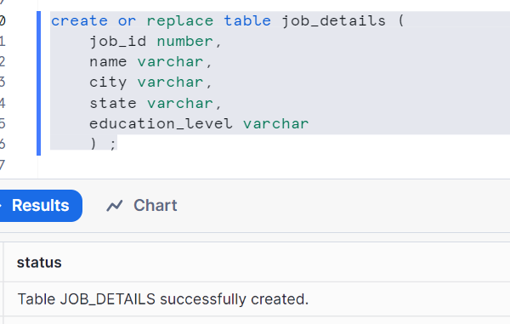
Inserting records
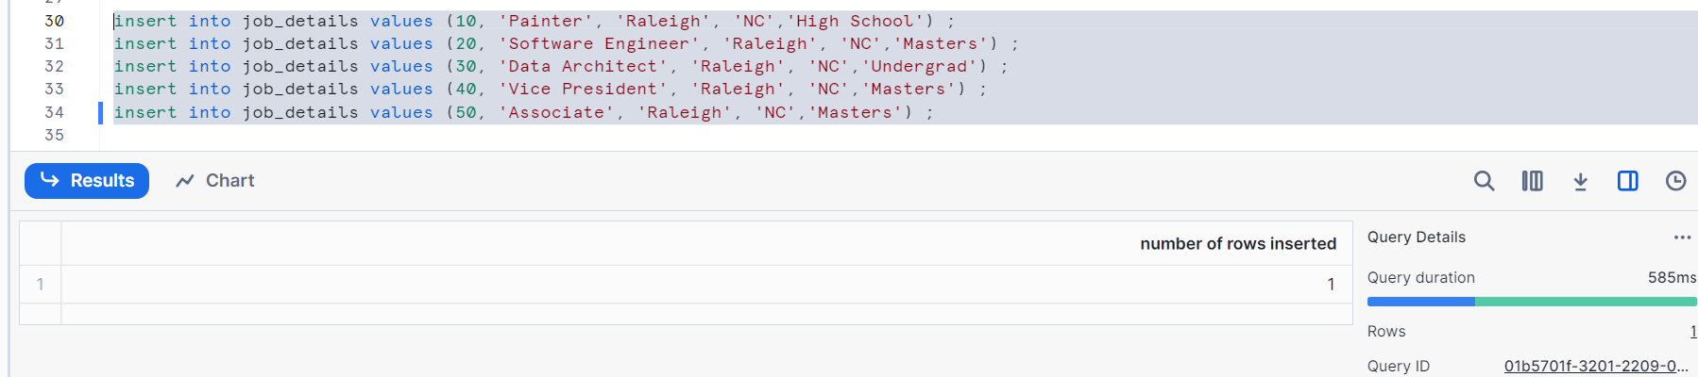
Check the data
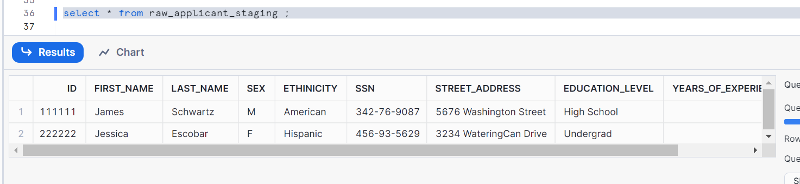
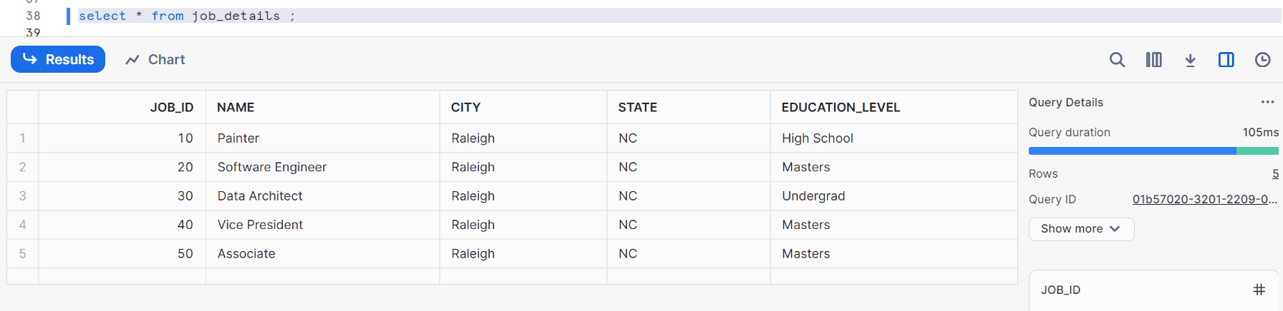

Create a dynamic table candidates as shown
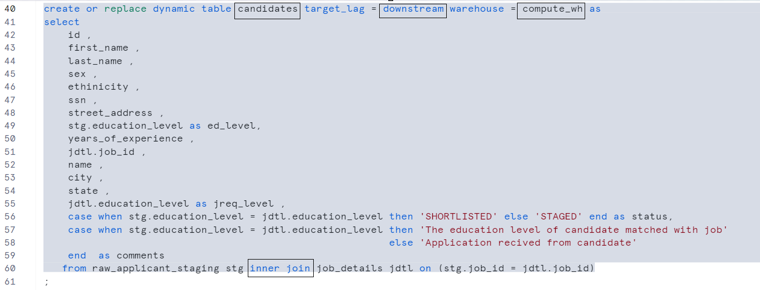
Now creating another dynamic table on previous dynamic table, here it is
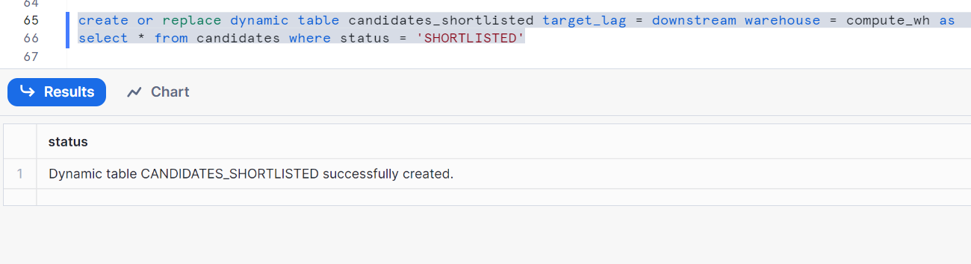
Note: target_lag =downstream implies your data never gets refreshed in dynamic tables when you insert extra records in your tables, it would be the same forever

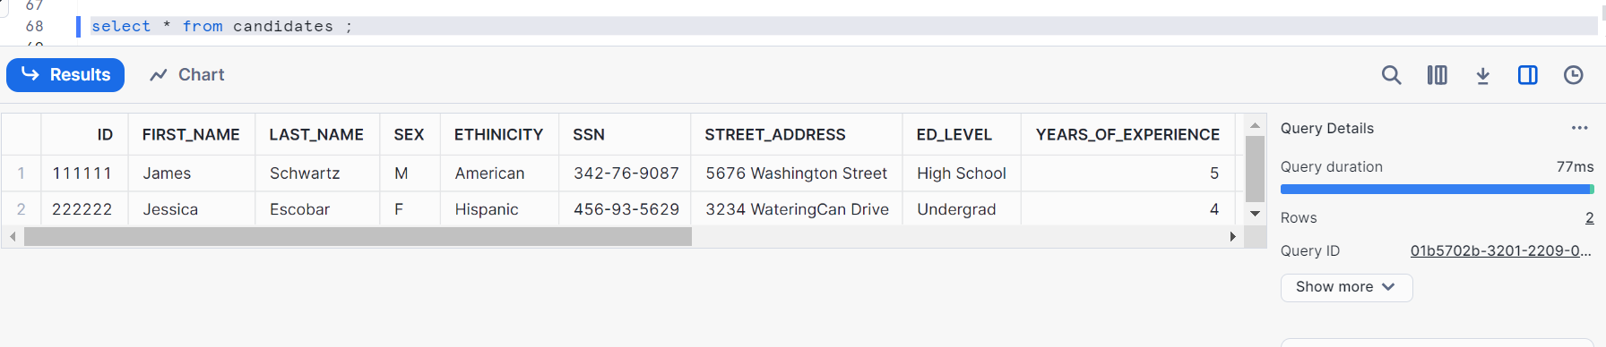
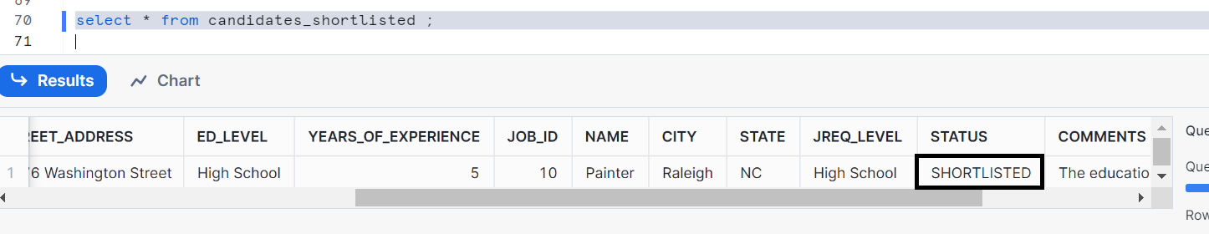
Note:
If it shows you error, so manually the table need to be refreshed
Here is the syntax
Alter dynamic table candidates refresh;
Alter dynamic table candidates_shortlisted refresh;
Now, let’s us Check the graph in snowflake UI and see how our data pipelines got created

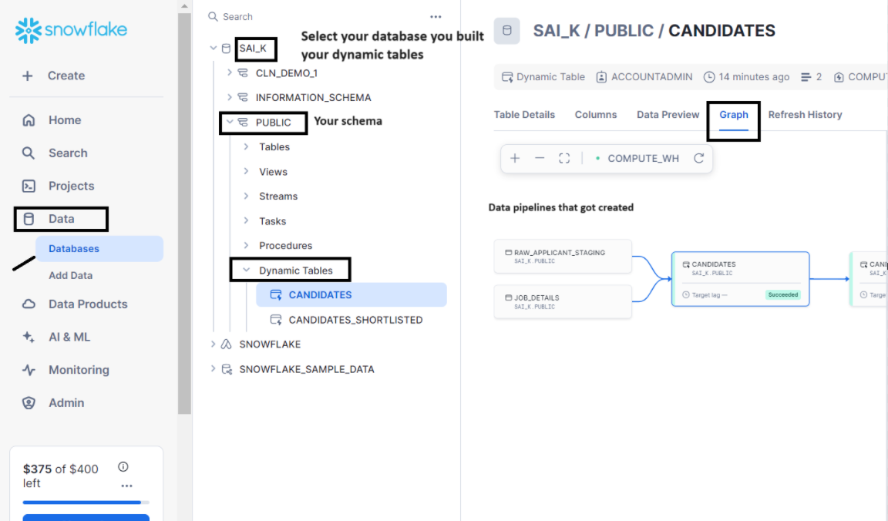
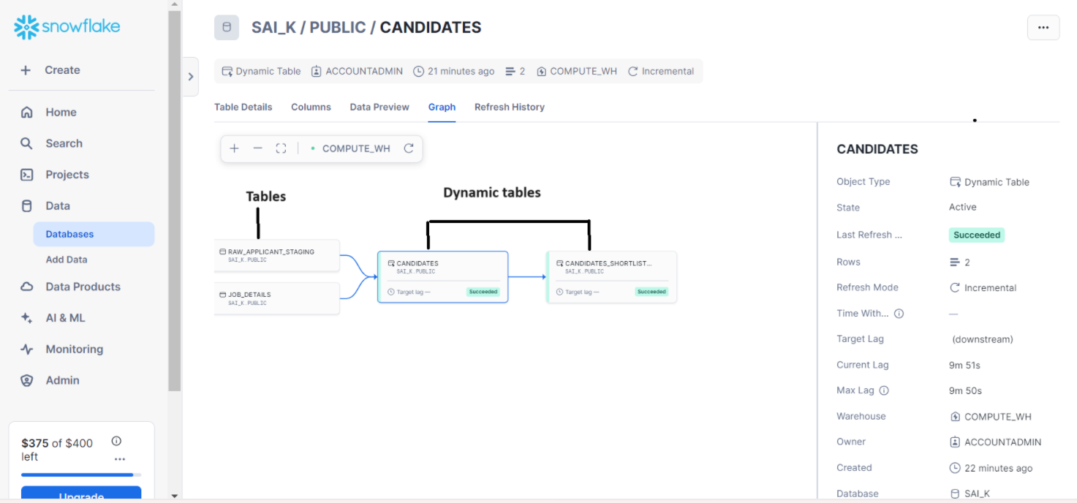
Let’s check the graph via SQL
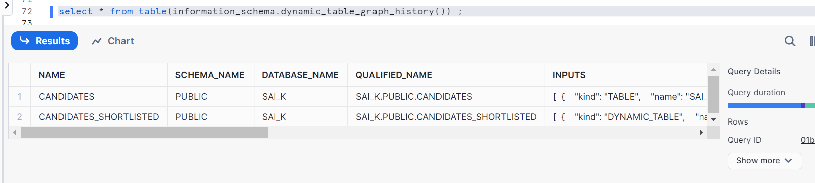
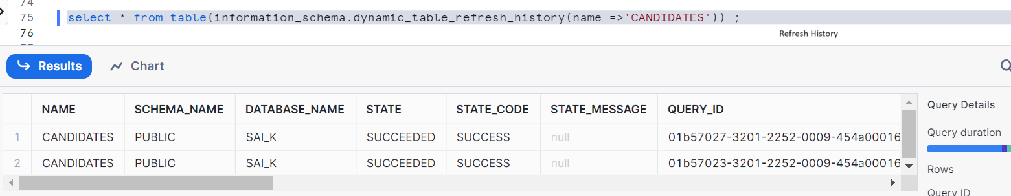
Change the target lag to 1 minute and then insert the data in our staging and contacts, see whether data getting refreshed or not
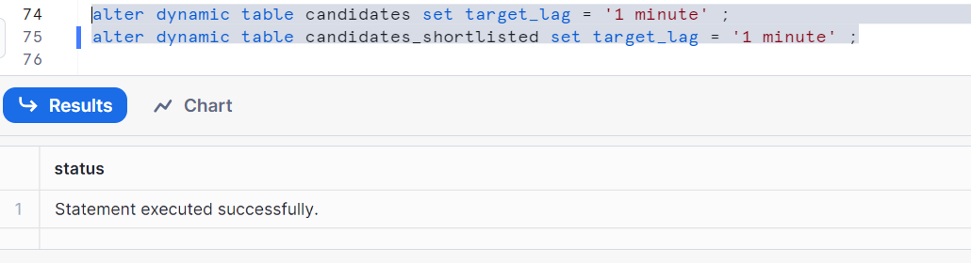
Let’s insert the data and wait for 1 min to check
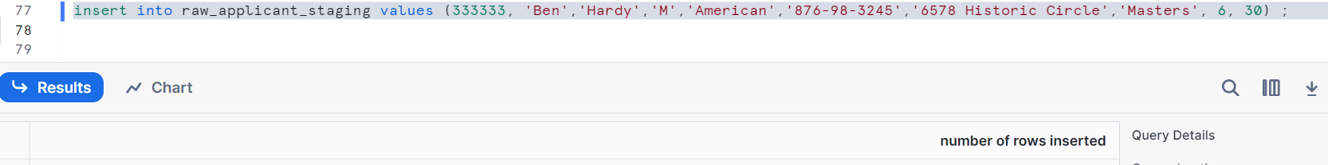
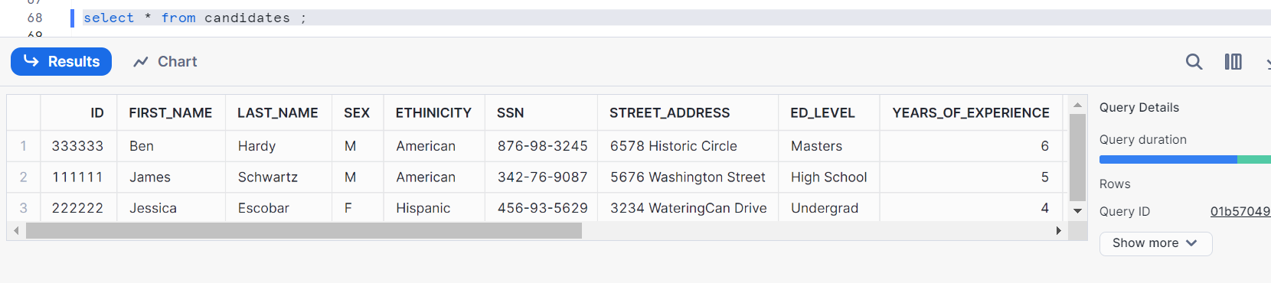
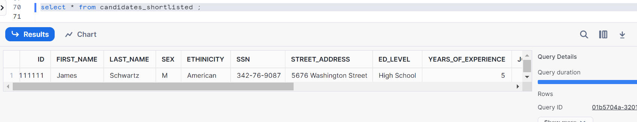
As in candidates, id 333333 status is ‘staged’, hence you don’t get that record in candidates_shortlisted as it only takes status= ’ SHORTLISTED’

